This permit is required to transport Non-Weapon Radioactive Material and/or Radiation Generating Devices on/off the Pantex Plant site.
Pantex authorizes to transport the following non-weapon radioactive material and/or radiation generating devices on the Pantex
site for the period of through
for the purpose of .
Equipment | Source | Manufacturer | Serial Number | Model Number | Activity | Leak Test Due

On Site Source Leak Test Requirements
Entry Leak Test Required YES NO
Exit Leak Test Required YES NO
Contact Radiation Safety Department (RSD) for Leak Test at 477-5726, 477-7663, 477-4177, 573-8664 or digital pager 345-1456.
Approved:
Radiation Safety Technician Signature/Badge Number Date
Approved:
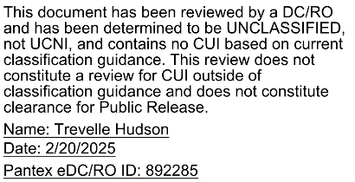
RSD Section Manager Signature/Badge Number Date

