
Subcontractor & Uncleared Visitor Training
Course: ST 553.05
A


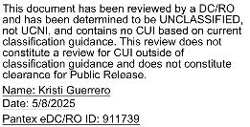

Table of Contents
Security Awareness and Operations Security (OPSEC) 6
Identification of Prohibited and Controlled Items 8
Medically Necessary Portable Electronic Devices (MEDPED), Metal Implants, Prosthetics and Medical Support Aids 10
Foreign National Interaction and Involvement 10
Public Release of Information and the Information Release Process 10
Identification of protection and control procedures for controlled unclassified information (CUI) 11
Reporting Security Concerns 11
OPSEC Principles 11
Working Atmosphere 12
Substance Abuse Program 13
Beryllium Awareness 14
Counterintelligence at Pantex 14
Emergency Preparedness 15
Environmental Management System (EMS) 21
Hazardous Chemicals 23
Traffic Safety 23
Warning Signs 24
Footwear Policy 24
Integrated Safety Management (ISM) 25
Explosive Hazards & Identification 27
Differing Professional Opinions (DPO) Process 28
General Employee Radiation Training (GERT) 29

Welcome to Pantex!

The staff would like to welcome you to the Pantex Plant. The following pages will provide important information in which you are required to read and comply. Failure to comply with the rules and requirements of the Pantex Plant could result in immediate removal of access privileges and, in some circumstances, civil and/or criminal prosecution. If you have any questions after reading this information, please ask your escort or point-of-contact for clarification.

After reading the following information, a Training Completion Report, PX-3864, must be completed in order to receive credit in the Pantex Learning Management System (LMS). The following page illustrates the proper way to fill out the PX-3864. All highlighted areas must contain the information requested. The completed form is to be left with Access Control personnel before entering the facility.

Contact the section Point of Contact (POC) for questions or clarifications about the information contained within this book. For general information, contact Kristi Guerrero, 806-477-6263.

Have a safe and security conscious visit to the Pantex Plant.

Document Symbols



This symbol indicates a point of contact for more information.

This symbol indicates an important note.




Security Awareness and Operations Security (OPSEC)

Point of Contact

Security Awareness Mike Hight (806) 477-4248
OPSEC Alma Farr (806) 477-7610

Pantex Mission:
Pantex is responsible for maintaining the safety, security and reliability of the nation’s nuclear weapons stockpile.

Overview of Pantex Safeguards and Security (S&S) responsibilities
There are six primary functions within the S&S Program:
- Program Planning and Management establishes planning and management requirements for the overall S&S program.
- Information Security establishes security requirements for the protection and control of information and matter required to be classified or controlled by statutes, regulations, or DOE directives; includes protection of sensitive data about our people, facilities, processes, activities, and technologies.
- Personnel Security assures that individuals with access to classified information and Special Nuclear Material (SNM) do not pose a threat to the nation’s security. Personnel Security coordinates background investigations for all prospective employees to ensure they are eligible, under DOE requirements, to receive an access authorization (security clearance).
- Physical Protection establishes requirements for protection of the physical aspects of security, including access control, alarms, barriers, and security systems installation and maintenance.
- Protective Force exists for the protection of Special Nuclear Material, personnel, information, the environment, and government property from theft, diversion, sabotage, and malicious acts that could impact national security or the health and safety of employees and the public.
- Nuclear Material Control and Accountability (NMC&A) provides management, control and accountability for all nuclear materials.

Access Control
Access Control is the process of permitting or denying access to information, facilities, nuclear materials, resources, or designated security areas. Access Control measures include hardware and software features, physical controls, operating procedures, and administrative procedures designed to detect or prevent unauthorized access to Department of Energy interests.

Escort Procedures

In some areas of the plant, visitors and sub-contractors must be escorted. The individual providing the escort is responsible for oversight and control of personnel in a security area who do not have the proper need-to-know or access authorization for that particular area. If you must be escorted in order to conduct your work at Pantex, it is your responsibility to stay with the person escorting you at all times. Failure to follow your escort’s guidance or direction can result in immediate – and possibly permanent – removal from Pantex Plant.

Protection of Government Property

All employees are responsible for government-owned property provided for their use.

Property removal

Government-owned property may not be removed from the Pantex Plant for any reason other than for official business or DOE/NNSA approved activities. Employees must have an approved property pass before removing government property from the plant.

Potential penalties

Conversion of government-owned property to personal use, misuse, or abuse is prohibited and punishable up to and including termination. Acts of theft or unlawful possession of property may result in fines of $1,000 to $10,000 and/or 1 to 10 years of imprisonment.

Badge Procedures

Security Badges are your identification and will allow you access into Pantex facilities. Security badges are issued at Access Control in Building 16-12. A security badge is issued only after an employee has been approved for access.

Wear Badge

Badges must be worn at all times while on DOE property. Place badge photo side out on the outer most piece of clothing, in a location above the waist.

Lost Badge
If you lose your badge, report to Access Control, Building 16-12.

Stolen Badge

If your badge is stolen, report it immediately to Access Control at (806) 477-3908 or (806) 477-3909. If it is after hours, call the Operations Center (OC) at (806) 477-5000. A report must be filed with the local law enforcement agency and provided for an Incident of Security Concern (IOSC).

Forgotten Badge

If you forget your badge, you may choose to return home or Access Control can issue a temporary badge for one day.

- Badge Replacement - Your badge must be replaced if:
- Your contract company changes
- Your name or physical appearance changes
- It is faded or damaged
- When directed by a Security Police Officer

Badge Verification

When entering Pantex, the security badge is used as verification to ensure only authorized personnel have access to the facility. Upon entering the Pantex facility present your badge for examination by the Security Police Officer or use the automated Argus System.

Badge Surrendering

Pantex employees, consultants, and contractors on leave for 30 consecutive days or those who will be gone for an unknown time period must return their badge to Access Control, Building 16-12. Security badges are the property of DOE and shall be returned to Access Control upon request, expiration, when no longer valid or required, or upon termination.

Badge Cautions
- It is against the law to counterfeit, alter, or misuse your badge.
- Do not use the DOE standard badge outside the Pantex facilities unless it is for an official government purpose.
- Remove badge when off-site.
- Protect your badge from theft; do not leave your badge in plain view or in your vehicle.

Questions about badges or badging procedures should be directed to (806) 477-3908 or (806) 477-3909.

Identification of Prohibited and Controlled Items

IMPORTANT: Devices with a camera, any Bluetooth capability, or any WIFI Hotspot capabilities are strictly prohibited from use at Pantex. These capabilities on the devices must be disabled when removed from personal vehicles on plant site. All activities involving controlled articles will be investigated and may result in disciplinary action, up to and including termination.

Prohibited Items
The following items are NEVER allowed ANYWHERE on-site at Pantex, unless prior authorization has been received from Safeguards & Security Division.

Any type or amount of the following:
- Alcohol
- Ammunition
- Arrows
- Blackjacks
- Chemical dispensing devices for pepper spray, mace, etc.
- Clubs
- Drug paraphernalia
- Controlled substances
- Drugs (prescriptions are allowed as long as they are prescribed for the employee who is using them. Medical must be notified of medication use.)
- Compound bows
- Crossbows
- Explosives
- Explosive devices
- Fertilizer
- Firearms
- Illegal drugs
- Items that could be used to manufacture explosives
- Incendiary devices
- Knives with blades 2.5 inches or longer
- Knuckles
- Nightsticks
- Nunchucks
- Stun guns
- Swords
- Technical Surveillance Equipment (i.e. any equipment specifically designed to clandestinely collect information)
- Zip guns

Controlled Items
The following are examples of controlled items that are allowed on-site at Pantex, but MUST remain in personal vehicles in the Property Protection Area. Subcontractors MUST remove all controlled items from person, vehicle, and property prior to entering the Limited Area.

Any type or amount of the following:
  - Cameras – At no time are pictures to be taken anytime on plant site with any type of personal equipment.
  - Telephones (all types including cellular, and satellite)
  - Computer Components
    - Cellular wireless cards
    - Wireless cards
      - Exception: Wireless cards issued for laptops in transit between 16-19 and your car
    - Any device with Bluetooth capability
    - Any other computer component or peripheral
  - Computers not owned by Pantex – Exceptions for this category are given on a case-by-case basis by the Information Systems Security Site Manager (ISSM) or their designee.
    - Laptops/Netbooks
    - Smart phones/PDAs (i.e. iPhones)
    - Media players (i.e. iPods)
    - Tablets, pads, and slates (i.e. iPads)
    - Game devices (i.e. PSPs)
    - Any other device with a processor and storage
  - Global Positioning Systems (GPS) – (e.g., Portable (Transmit/Receive))
  - On-Star
  - Personal software
  - Radio frequency (RF) devices (Note: key fobs ARE allowed except in Nuclear Explosive Areas)
  - Recording devices (optical, video, audio, or data)
  - XM or Sirius radio receivers with recording capabilities
  - Any privately owned device, electronic or optical, capable of recording, processing, storing or transferring audio, computer data, video or photos

Basically – if you can plug it in, if you can upload, download, or transmit information with it, leave it in your personal vehicle in the Property Protection Area.


NOTE: Government-owned equipment must be pre-approved and documented before it can be brought onto the plant site. Employees planning to purchase electronic equipment for use at work should contact the Technical Security Office prior to purchase.

Electrical Devices are not permitted into a Nuclear Facility with the exception of non-transmitting watches, non-transmitting pagers, hearing aids, and internal medical devices that do not have defibrillator capabilities. All other electrical devices or medical equipment should be reported to Pantex escorts to identify allowable facilities.

NOTE: Pantex issued pagers are the only authorized pagers allowed for site-wide use. All other pagers (government or personally owned), must be evaluated and approved through the PXD technical review process.

Medically Necessary Portable Electronic Devices (MEDPED), Metal Implants, Prosthetics and Medical Support Aids

Visitors requiring use of MEDPEDs, metal implants, prosthetics and medical support aids during their visit must have a completed PX-6390 (Personal Medical Electronic Device Allowance Request Form) submitted in order to have the item(s) approved for use at the facility before the scheduled visit.

Your visitor host is responsible to ensure the PX-6390 is completed and processed. All required approvals must be in place before your access is granted.

Once your device is approved, a medical allowance card will be issued with any restrictions identified.

Foreign National Interaction and Involvement

A foreign national is any person who is not a US citizen as documented by required documents. Contact your site technical representative (STR) or Procurement if you require bringing a foreign national on a project that involves PXD information. Only a DOE cleared US citizen who is permanently assigned to Pantex can request a foreign national visit. Do not seek access for any foreign national without being notified by the Security Foreign National Visit Coordinator that the proposed foreign national visit is approved. Do not bring foreign nationals on-site or hand them PXD information without approval from the Pantex Export Office.

Uncleared Foreign Nationals
If you are an uncleared foreign national, you must comply with your host’s directions and the directions of security personnel. You will be continuously under escort and subject to search and security measures. You will only be given approved access to certain locations and you must comply at all times with security and host instructions.

You must immediately notify your host of changes in name, immigrant/nonimmigrant status, and other information as required. If you are involved in any civil or criminal issue you must notify your host immediately. You must provide appropriate documentation when required. Providing fraudulent documentation will result in suspension of access approval, removal from the site, and possible cancellation of future access.

Public Release of Information and the Information Release Process

You are reminded that only those employees that have been specifically designated to speak for PXD to the media are authorized to do so. If you are contacted by any media personnel for your comments on Pantex information, you are directed to refuse the request, and recommend that they contact the Pantex Public Affairs Department (E-POL-1001).

If you are asked to publicly contribute to a professional publication about Pantex information, you must submit the content and justification for review by submitting a request to the Pantex Information Release Office (IRO) System (IROS). See E-PROC-0046 or email IRO@pantex.doe.gov for more information.

Information found in the public domain to be sensitive to Pantex or Pantex employees will be handled according to federal law, DOE orders, and the Pantex Employee Manual (MNL-00018). Acts of misconduct, neglect and/or unauthorized public disclosures about Pantex are strictly prohibited and may result in criminal and/or civil penalties.

Violations may also result in disciplinary action by the company up to, and including, termination.

Identification of protection and control procedures for controlled unclassified information (CUI)

Please read the Uncleared Subcontractor UCNI/CUI Information Packet. This should be provided to you upon receipt of this booklet as a pamphlet and also found electronically on www.pantex.energy.gov .
NOTE: Should you have any questions or concerns regarding the identification or Classification in general of CUI and UCNI, please contact Marley Hoggatt at (806) 573-6754.

Reporting Security Concerns

It is everyone’s responsibility to help deter, detect, and prevent an incident of security concern. Incidents of security concern are actions, inactions, or events at Pantex that:
- Pose threats to national security interests and/or critical DOE assets,
- Create potentially serious or dangerous security situations,
- Potentially endanger health and safety of the workforce or public,
- Degrade the effectiveness of the Safeguards & Security programs, or
- Adversely impact the ability of the organization to protect DOE safeguards and security interests.

Any attempt to gain unauthorized access to classified information or matter, or any time classified is left unattended or unprotected are all considered Incidents of Security Concern.

When Should YOU report an Incident of Security Concern?

Immediately! Any person, who observes, finds, has knowledge or information about a potential incident of security concern must immediately report the information to their supervisor or the Operations Center.

OPSEC Principles

It is a privilege to support our military forces and to serve our country in a unique mission by protecting and controlling Pantex information. Accomplish this honor by carrying out the OPSEC Principles:

Own It – Information protection is everyone’s responsibility.

Protect Our Mission – yourself, families, communities, and national security.

Secure It – Secure all assets.

Ensure – To use countermeasures (e.g., do not discuss/post Pantex information in public, protect paperwork, badges, etc.)

Contact OPSEC@pxy12.doe.gov – “See Something, Say Something!”

Working Atmosphere

Point of Contact

Ellen Fulton (806) 573-6887

Working Atmosphere Policy Against Harassment of Employees
Visitors and employees at Pantex Plant have a responsibility for maintaining high standards of honesty and integrity, and for conducting themselves in a way that will assure proper performance of the Company's business for the government.

Working Atmosphere
It is the policy of Pantex Plant to provide a working atmosphere free of discriminatory insult, intimidation, and other forms of harassment. All employees and visitors share the responsibility for fostering a pleasant working atmosphere that allows individuals to achieve high performance in their duties. State and federal anti-discrimination laws prohibit harassment.

Harassment
Harassment based on race, age, color, religion, gender (including sexual harassment), gender identity, sexual orientation (including sexual orientation harassment), national origin, ancestry, genetic information, protected veteran status or disability is prohibited. Employees and visitors are also protected from retaliation or reprisal for expressing concerns individually or in groups, or raising allegations of prohibited discrimination. Harassment may be overt or subtle. However, whether it takes verbal, nonverbal, or physical form, harassment is insulting and demeaning to the recipient. Examples of harassment include, but are not limited to the following: verbal abuse, racial, ethnic and religious epithets, slurs or jokes, graffiti (remarks written or drawn on walls or other structures), obscene gestures and hazing. Even derogatory remarks shared between friends who are members of the same protected group may lead to overt acts of discrimination. The Company will not tolerate harassment at Pantex Plant.

Sexual Harassment
Sexual harassment is intolerable in the workplace and is defined to include, but not limited to:
- Making unwelcome sexual advances.
- Explicitly or implicitly making requests for sexual favors and other sexually oriented verbal or physical conduct a term or condition of employment.
- Explicitly or implicitly making requests for sexual favors and other sexually oriented verbal or physical conduct the basis for employment decisions.
- Creating a working environment that is offensive or interferes with work performance.

The Company prohibits all sexual harassment at the Pantex Plant.

Employee and Visitor Responsibility
Employees and/or visitors who believe that they or others are the victims of harassment should promptly report the harassing conduct to management. Personnel should report incidents to the immediate supervisor, any other member of management, or the Ethics & Employee Concerns Office.

Management Responsibility
Company management and subcontractors are responsible for assuring that no harassment occurs within their area of authority. Managers should give immediate attention to complaints of harassment and should report the complaints to the Ethics & Employee Concerns Office.

The Ethics & Employee Concerns Office and the reporting manager will conduct investigations, which may include conferring with the parties and witnesses named by the complainant. Because of the sensitive nature of such complaints, the Ethics & Employee Concerns Office and the reporting manager must investigate the incident with particular care and the incident should remain, to the extent possible, strictly confidential.

Sanctions
If the investigation reveals that the complaint is valid, the Company will take prompt action to stop the harassment immediately and to prevent its recurrence.

Harassment by Non-company Contractors
Should investigation reveal that an employee or visitor has become the victim of harassment or sexual harassment by a non-company contractor with whom the employee has work-related contact, it will be the responsibility of the Ethics & Employee Concerns Office to act accordingly in dealing with the vendor, contractor or other employer of the person involved.

Sexual Harassment Policy
Sexual harassment is a form of misconduct that undermines the high standards of integrity and honesty established by the Company. Specifically, federal regulations define sexual harassment as the deliberate, unwelcome or repeatedly unsolicited verbal comments, gestures, or physical contact of a sexual nature.

Any employee or visitor who participates in deliberate or repeated unsolicited verbal comments, gestures, or physical contact of a sexual nature is engaging in sexual harassment and is also interfering with work productivity.

The Company prohibits the display of sexually suggestive visuals such as pinups, calendars, posters, cartoons, quotes and/or signs. Such displays could create a hostile work environment, which is a form of sexual harassment.

The Company will not tolerate sexual harassment in the work environment. Employees or visitors should report sexual harassment to a member of the supervisory chain or to any designated Company contact.

For additional information or questions, contact the Ethics & Employee Concerns Office, (806) 573-5348.

Substance Abuse Program
The Pantex substance abuse program complies with all applicable federal requirements. All subcontractors at Pantex are subject to for-cause (reasonable suspicion) and post incident, injury, accident or occurrence testing for illegal drugs and/or being under the influence of alcohol. Subcontractors that test positive for illegal drugs or alcohol misuse will permanently lose site access.

Beryllium Awareness

Points of Contact

Ken Meyer (806) 573-4209
Corbin McGill (806) 573-7548

Beryllium is a lightweight metal. Beryllium dust can cause lung disease if inhaled. Beryllium is NOT radioactive.

Only a small percentage of the human population has the potential to be affected by beryllium. If you are reading this information, you are not expected to have any exposures. This information is for your general awareness and you will be given additional information if you are assigned to work in potential exposure areas.

Normal operations and maintenance do not release beryllium into the air. When there is a chance of releasing beryllium, exhaust systems are used, if possible, to capture the dust at the point of generation. Respirators are sometimes required if exhaust systems cannot be effectively used.

Pantex has also identified facilities with beryllium contamination from past operations. All active facilities that were previously contaminated have been cleaned to allowable levels as required by federal regulation for a safe workplace. These facilities have been released for normal operations and maintenance. Any demolition or other modifications to these facilities require a beryllium work permit which will specify protective equipment and controls.

Beryllium Medical Surveillance Program
Pantex Occupational Health Services (OHS) offers beryllium testing (called Be-LPT) to anyone who feels they have been exposed to beryllium. The beryllium test is a voluntary blood test used to identify individuals who have acquired a sensitivity or allergy to beryllium.

For questions about beryllium issues or work place monitoring, contact Industrial Hygiene at (806) 573-4209 or (806) 573-7548. For questions about medical testing for beryllium, contact Occupational Health Services at (806) 573-4774.

Counterintelligence at Pantex

Points of Contact

Pantex Field Office, DOE Counterintelligence (806) 477-5374
Anonymous Tip Line (806) 477-6007
Email: CI@pantex.doe.gov

To mitigate the threat to Pantex employees from both insider and foreign collection attempts, the DOE implements a required reporting system. If you, or a fellow Pantex employee, experience any of the following, you must report it to the Pantex Field Office:
  - All foreign travel – this includes embassies or consulates in the U.S.
  - Any substantive professional, personal, or enduring financial relationship with sensitive country foreign nationals
  - Any contacts with foreign nationals who make requests that could be attempts at exploitation or elicitation
  - Requests for unauthorized access to classified or otherwise sensitive information
  - Unusual solicitations (anyone of any nationality)
  - Anomalies (indicators that someone has access to information they should not know)

Additional information can be obtained from your Pantex Field Office and the Counterintelligence web site, located on the Pantex intranet. The Pantex Counterintelligence Team is here to support national security initiatives and encourages each employee to report any suspicious activity.

Emergency Preparedness

Points of Contact (including Emergency Numbers)

Operations Center (806) 477-5000 (24 hrs.)
Emergency Services Dispatch (806) 477-3333 (24 hrs.) for Fire or Medical Emergency Radiation Safety (806) 477-5555 (24 hrs.)
Security (806) 477-3922 (24 hrs.)

Although most of the Pantex emergency planning and emergency preparedness responsibilities are addressed by the Emergency Management Department, emergency preparedness is part of everyone’s job. If there is an emergency, site-level drill or exercise, you should participate by responding appropriately for the event.

As a visitor/contractor to the plant, your Point of Contact (POC) is the person/group that is sponsoring your visit. Questions regarding emergency procedures or protective actions can be addressed by your POC or immediate job supervisor. If you are under escort by a Security Police Officer, the officer will provide direction for protective actions.

Individual Responsibilities
It is your responsibility, regardless of your employer or contracting tier, to take appropriate protective actions when you discover or receive a report of an unsafe condition. These responsibilities include, but are not limited to:
- Take actions to ensure your safety.
- Warn other personnel in the immediate area of the unsafe condition.
- Take actions to isolate the unsafe condition, if appropriate.
- Notify your POC/supervisor and the appropriate Plant emergency services of the unsafe condition.
- Assist co-workers and other personnel with implementation of protective actions, if necessary.
- Follow directions provided by emergency response personnel or as communicated by:
- Public Address (PA) announcement
- Alpha-numeric page
- Two-way radio
- Outdoor warning sirens activation (personnel should seek additional information as to whether the sirens were activated for severe weather or a hazardous materials release).

Announcements that are precursors to additional potential weather warnings.
While the above-mentioned notification systems should provide warning to the vast majority of plant personnel and visitors, each individual must exercise common sense and general safety awareness. For example, if you are working outdoors or preparing to work outdoors with a storm approaching and you are not aware of any weather warnings, contact your POC/supervisor or the Operations Center, (806) 477-5000, to confirm any weather warnings that might be in effect at the current time.

The following warnings (except for the tornado warning) have no specific personnel protective actions associated with them, beyond providing a precursor to additional potential weather warnings. However, all personnel should use caution when going/working outdoors and contact your supervisor/POC for further direction.
- “Lightning Warnings are in effect” - Lightning strike within 35 miles of the Pantex Plant.
- “Lightning Warnings with Personnel Safety Conditions are in effect” - Lightning strike within 10 miles of the Pantex Plant.
- “Severe Weather Warning for High Winds is in effect” - The National Weather Service (NWS) has issued a “High Wind Warning” for an area that includes the Pantex Plant.
- “A Severe Weather Warning with Personnel Safety Conditions for High Winds is in effect” - weather information source(s) indicates 50+ mph sustained or gusty winds at or near the Pantex Plant.
- “The National Weather Service has issued a Severe Thunderstorm *Watch - Plant personnel should remain alert for possible severe weather warnings.” The NWS has issued a Severe Thunderstorm Watch for Carson County.
- “A Severe Thunderstorm *Warning is in effect” - All plant personnel should remain indoors. The NWS issues a “Severe Thunderstorm Warning” for Carson County or any of the eight surrounding counties.
- “The National Weather Service has issued a Tornado *Watch. Plant personnel should remain alert for possible severe weather warnings.” - The NWS has issued a “Tornado Watch” for Carson County.
- “A Tornado *Warning is in effect. All plant personnel Seek Shelter from Severe Weather immediately. Cease operations, cease transportation activities, and place materials in a safe and stable configuration.” - The NWS has issued a Tornado Warning for Carson County or any of the eight surrounding counties or there is a report of a tornado, funnel cloud, or rotating wall cloud near the Pantex Plant by Plant personnel. (Seek Shelter from Severe Weather procedures will be discussed in the protective actions section.)
- “A Flash Flood *Watch is in effect.” Plant personnel should stay alert to changing weather conditions. Use caution when going outdoors.
- “A Flash Flood *Warning is in effect.” Do not walk or drive over flooded roadways and areas. Use caution when driving.

Definitions of NWS, watch and warning:
Watch–a watch is used when the risk of a hazardous weather has increased significantly, but its occurrence, location, and/or timing is still uncertain. It is intended to provide enough lead time so that those who need to set their plans in motion can do so.

Warning—a warning is issued when hazardous weather is occurring, is imminent, or has a very high probability of occurring. A warning is used for conditions posing a threat to life or property.

Protective Actions
Protective actions may be necessary in the event of emergency. The most prevalent protective actions for personnel at the Pantex Plant are:
- Avoid the Area
- Shelter for Hazardous Material Release
- Shelter for Severe Weather
- Shelter for Security Event
- Active Assailant/Hostile Incident
- Evacuation
These actions may be used individually or in combinations, as the situation warrants.

Shelter for Hazardous Material Release
Shelter-in-Place for Hazardous Material Release is a standard protective action to protect personnel from an airborne hazardous material release (either radiological or chemical). Ask your supervisor or POC if you need more information. If you are directed to Shelter-in-Place for Hazardous Material Release:
- Move indoors (if outdoors).
- Move to the innermost area of the building or structure (put as many barriers as possible between you and the outside environment).
- Close exterior doors and windows.
- Close as many interior doors and windows within the building as possible.
- Turn off and cover exhaust fans (laboratory hoods, bathroom vent fans, kitchen fryer hoods, etc.), if possible.
- Turn off air conditioners, heaters, and air-handling units that draw in outside air, if possible.
- Refrain from eating, drinking, smoking, applying cosmetics, using tobacco products or chewing gum. Remain inside until either an “All-Clear” message or other instructions are received from the Operations Center or your supervisor.
- If you are in a vehicle and need to Shelter-in-Place for Hazardous Material Release, roll up windows and close vents that draw in outside air (including heater and air conditioning vents). Proceed to a safe area that is upwind of the incident area.
- Personnel with Medical Conditions If you have a pre-existing medical condition and are required to take medication during a Shelter-in-Place for Hazardous Material Release emergency, be sure you follow these guidelines prior to taking medicine or injections:
- Wash your hands, face, and/or the injection area.
- Proceed with administering of medication.
- Report to the Occupational Medicine Department after termination of the emergency protective action.

Shelter for Severe Weather

Seek Shelter from Severe Weather is the protective action taken to protect personnel from the effects of severe weather. Employees and visitors are directed to seek the best shelter available in the amount of time available. To assist in making this decision, a sampling of Plant structures is listed below by general type and in order of declining level of protection:
  - Sturdy or rugged buildings like 12-130, 12-37, 12-75, 12-116, bays or cells (highest level of protection)
  - Brick buildings without windows
  - Brick buildings with windows
  - Cinder block buildings
  - Metal buildings
  - Temporary buildings and/or modular trailers (lowest level of protection)

If time permits, move to a more substantial building. However, it is safer to go to the center of a modular trailer than to be caught outdoors by a tornado while trying to get to a more substantial building.

If inside a building, the safest place is on the lowest level, in a small room in the interior portion of a building, away from all exterior doors and windows. Put as many walls as possible between you and the outside of the building to provide additional protection. If you cannot get to the lowest floor, center hallways are often the most reinforced part of a building.

Once you are in the safest location available:
- Protect yourself under a sturdy object, such as a heavy table or under stairs (modular office furniture is not suitable).
- Hold onto the sturdiest object available.
- Remain in place until the danger has passed and an “All Clear” message is received from the Operations Center (usually over the PA system).

Shelter for Security Event

The Shelter for Security Event protective action involves a series of protective measures implemented by the Protective Force and plant personnel to maximize the protection afforded national security assets and minimize the risk to plant personnel health and safety during an actual or potential security-related event or incident. These protective measures may be implemented individually, or in combination with other actions, to enhance the effectiveness of the Protective Force response and mitigate the consequences associated with event culmination, while limiting the exposure of plant personnel to adverse impacts.

The Shelter for Security Event protective action may be specific to an area or event. Subsequently, plant personnel must be attentive to public address (PA) announcements, pager messages, and instructions from Security personnel or other emergency responders, and implement the directed actions as quickly as possible.

Response:
Stop work.
Secure classified materials/systems/repositories.

Cease operations, cease transportation activities, and place materials in a safe and stable configuration. Report to, or remain at, your designated shelter location. (Shelter for Security Event may be applied to a building/facility, zone, or the entire plant.)
- Implement personnel and/or material accountability if directed by the OC or emergency response personnel.
- Implement Deny Access protective measures, if applicable to your work location.
- Restrict movement in ramps between security zones or the entire plant.
- Secure access to shelter location, if possible.
- Stay clear of doors and windows.
- Contact the Operations Center, (806) 477-5000, to report suspicious personnel or activities.
- Evacuate a building/facility, zone, or the entire plant at the direction of emergency response personnel.

Building Evacuation
You may need to evacuate an area as result of emergency or as otherwise directed by a supervisor, Building Manager or PA announcement. If you are in another area of the Plant not affected by the building evacuation, then you should remain clear of the evacuated area and evacuation routes.

If evacuation is required:
- Evacuate the building using the safest and fastest route possible, avoiding the area of the emergency condition to the greatest extent possible.
- Travel to the evacuation destination (muster station, an alternate on-site location, or an off-site location) designated by emergency responders.
- A muster station is a specified location that is a safe distance and direction from the evacuated emergency scene. A muster station provides instructions on how to respond to a specific emergency, and a means of receiving and transmitting information. You will find maps for muster stations in most buildings on site. If your assigned muster station appears not to be in a safe location during an evacuation, immediately proceed in a safe direction and manner to another muster station and promptly report your location to the Operations Center, (806) 477-5000.
- Follow directions of Security Police Officers (SPOs), Firefighters, other emergency responders, or supervisors.
- Contact the OC at (806) 477-5000, advising the Plant Shift Superintendent (PSS) of the emergency condition, evacuated location, any emergency assistance required (i.e. injuries), any unaccounted for personnel from the evacuated location, and any other pertinent information.
- Do not attempt to reenter an evacuated building. Initial emergency responders are responsible for controlling access to the evacuated area.
- Follow the instructions posted or provided by the PSS, SPOs, firefighters, other emergency responders, or supervisors.
- Contact Radiation Safety at (806) 477-5555 if you evacuated because of a tritium alarm.
- Complete a PX-970 and provide the information to emergency responders and/or the OC.
- Remain at the muster station until given the all clear or otherwise directed by emergency response personnel or other competent authority.

Specific evacuation routes are not spelled out because they are dependent on the incident, its location, and the current meteorological conditions.

Personnel Accountability
Personnel accountability is a critical step in the protective action process, especially in conjunction with evacuation from an impacted facility. The objective of accountability procedures is to ensure that search, rescue, and/or assistance efforts can be initiated promptly to provide for the safety of building/facility personnel who may be injured, trapped, or unaware of the emergency condition. Additionally, a timely and accurate accountability of personnel can prevent the initial emergency responders (i.e. firefighters) from conducting a needless, and potentially hazardous, search and rescue mission.
- Muster Station Accountability - In the event of a building evacuation, muster stations have been identified for specific zones and buildings to allow for evacuated personnel to have a pre-designated location to report so that personnel accountability may be performed. Once at the muster station, personnel are to complete a PX-970 and submit it to the Operations Center. Building Wardens should have a general knowledge of personnel located in their facility, while Supervisors are responsible for knowledge of their personnel’s whereabouts (i.e., on plant site, off site, etc.). When the PX-6168 is received, the Plant Shift Superintendent (PSS) compares the personnel listed on the form to the PeopleSoft database for facility occupants to determine if personnel are missing.
- Plant-Wide Personnel Accountability - Although plant-wide accountability is not a specific program requirement, there are situations and/or strategic decisions where plant accountability information would be beneficial to the Emergency Manager. Use of Plant-Wide Personnel Accountability is initiated when an emergency situation necessitates the accountability of on-site personnel, including visitors and subcontractors; typically, in conjunction with Seek Shelter from Severe Weather or Shelter-in-Place for Hazardous Material Release protective action.


NOTE: In the event of any accountability, visitors and subcontractors to the site should always report to their POC, supervisor, or SPO escort as well as following site requirements.

Active Assailant/Hostile Incident
  - Actions taken based on a hostile threat in a building or area. The PSS/OC will notify employees of a hostile threat by announcing “Active assailant in Building XX‐XX” or “Hostile Incident in Building XX‐XX.” Occupants of the building are to take the protective actions based on a “run, hide, fight” approach.
  - Evacuate if a safe escape path exists.
  - Leave personal belongings behind.
  - Keep your hands visible.
  - Prevent individuals from entering an area where an Active assailant may be.
  - Follow the instructions of Security or police officers.
  - Call (806) 477‐5000 when you are safe.
o Report specific location (building and room), number of people, injures (if any), and assailant information including location, number of suspects, race/gender, clothing description, physical features, type of weapons (long gun or hand gun), backpacks, shooter’s identity (if known), and separate explosions from gun fire.
  - Hide out if evacuation is not possible.
  - Hide in an area out of the shooter’s view.
  - Lock and barricade the door.
  - Close blinds.
  - Turn off computers, radio, etc.
  - Silence your cell phone and/or pager.
  - Hide behind large items (e.g., cabinets, desks).
  - Remain quiet.
  - Act as aggressively as possible against the assailant.
  - Throw items and use improvised weapons.
  - Yell.
  - Commit to your actions.

Emergency Notification
The Plant Shift Superintendents (PSSs) monitor plant safety systems, including weather-related systems, to ensure plant personnel are provided with event-specific information as rapidly as possible. In addition to issuing directions to “Seek Shelter from Severe Weather,” if severe weather threatens the Pantex Plant, the PSS is responsible for issuing other protective actions, as well as the “All Clear” when emergency conditions no longer exist.

Fire Safety

If there is an indication of a potential fire, either by sight, smell, or activated alarm system, evacuate immediately. Evacuate potentially burning buildings by the nearest available exit. This reduces the potential for becoming lost in confusing and smoky conditions, overcome by rapidly developing fire, moving into the fire area, or hampering emergency response efforts.

If you are in a potentially burning building:
- If time allows, activate manual fire alarm pull station.
- Evacuate to the assigned muster station (only if the route is safe and not involved in the fire).
- Follow posted instructions, public address system announcements, or other provided directions.
- Remain at the muster station, or at a safe location away from the affected building(s), until an “All Clear” message has been issued by the Operations Center.

Environmental Management System (EMS)

Points of Contact

EMS Hotline (806) 573-4446
Jon Booker (806) 573-4354

Pantex is committed to excellence in environmental stewardship. Your Company has adopted the Pantex Environmental Policy that establishes the basic principles for conducting work within the Pantex boundaries. You are our partner in protecting the environment while you are working here. We encourage you to look for opportunities that exceed the basic criterion of compliance, whether in waste management, pollution prevention, energy conservation or in the use of recycled materials, to accomplish your work. Your active support will help Pantex maintain national recognition as a leading DOE/NNSA facility.

Spill Prevention and Control
Pantex maintains a plan for spill prevention and control. When a spill is observed, notify the Pantex Operations Center at (806) 477-5000 as a central point of command for the activity.

Energy Management
The vision of Pantex Energy Management is to provide sustained and superior energy management services, and to position Pantex to meet NNSA energy requirement needs through 2025 and beyond. Energy Management‘s mission is to incorporate renewable energy and energy efficiency technologies site-wide.

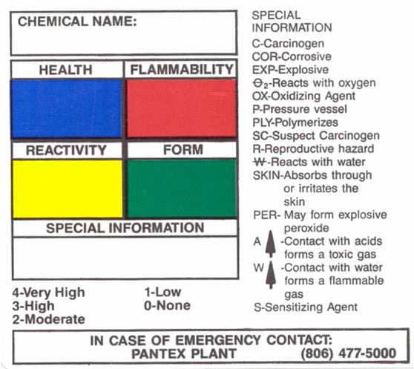
Hazardous Chemicals

Point of Contact
Brian Hildinger (806) 573-6486
Angie Bowman (806) 573-5929

At Pantex, hazardous chemicals are labeled with a Plant-specific label. The hazards criteria on the Pantex label vary slightly from the hazards on the National Fire Protection Association (NFPA) label.

Visitors and contractors must not bring any hazardous chemicals onto the Plant site without prior approval from Hazard Communication. When a chemical has been approved for use, the unused portion must be removed from the site when work is completed.

If a pregnant female reports her pregnancy to her supervisor, and the supervisor is unable to determine the reproductive hazards of the chemicals with which that employee works, they may send a list of chemicals, with Safety Data Sheets (SDS), to the Hazard Communication Group (HAZCOM) for analysis. HAZCOM and Industrial Hygiene will do the evaluation and return recommendations to the subcontractor supervisor.

Traffic Safety

Point of Contact
Laresa Halcom (806) 477-5969
Pantex encompasses a fairly large area that requires driving vehicles, so traffic safety is a major concern. Always wear your seatbelt. Because of special safety requirements, it is essential to obey all posted speed limits. Park in designated areas only. Traffic monitoring is in effect.

NOTE: Cellular phone use, both phone and text features, is prohibited while driving on plant site. Should you need to use your cellular phone, please pull over to the side of the road to do so.
NOTE: If any vehicle approaches you with its warning lights on, pull over, stop completely, and let the vehicle pass. Remain stopped until all vehicles in the group have passed. If you are following a group of vehicles with flashing lights, remain at least 300 feet behind. Never attempt to pass a convoy of vehicles or any vehicle with flashing lights!

You may encounter material moves within the ramps. Be alert. A Walker/Spotter, wearing an orange/red vest, escorts material being moved by forklift. If a material move is approaching, stop and move as far to the side of the ramp as possible. Remain there until it has passed. Remain at least 25 feet behind. Always follow the directions of the Walker/Spotter.

Warning Signs

Point of Contact
Phillip Lacy (806) 477-4228
As you move around the Plant, you may notice any number of warning signs. Heed them. Warning signs and barricades are common around construction sites, so be especially careful near these areas. Never enter a construction area without both authorization and the proper safety equipment. Never violate a barricade.

Footwear Policy

Point of Contact

Laresa Halcom (806) 477-5969

Proper footwear is a significant aspect of the Pantex Dress Code and is vital in meeting our internal safety goals. Employees should be aware of the role their footwear plays in minimizing injuries and promoting safety at work.

Pantex is an industrial worksite with great variation in quality of walking surfaces. All employees, regardless of the nature of their work, may encounter smooth surfaces, gravel surfaces, and/or uneven surfaces during the course of their work each day. All employees must wear appropriate footwear, as prescribed by safety requirements. This may include safety shoes and other personal protective equipment as required for employees working in operating areas, such as bays, cells, craft shops, labs and warehouses.

Employees working in areas where safety shoes are not required should remember that Pantex is an industrial site and wear adequate footwear.

Appropriate Footwear Requirements:
Footwear shall meet the following minimum requirements for Pantex.
- Heel height 2 ½ inches or less, as measured at back of the heel.
- Heel width (side to side) ½ inch or more as measured at the tread surface.
- Foot fully enclosed.
- Non-skid soles (Leather soles must contain non-skid material).

Additional footwear requirements are defined for entry into specific facilities or work areas and must be adhered to. Footwear such as flip flops, rubber sandals, open-toed, open-heeled and high heels (greater than 2 ½ inches in height and heel less than ½-inch diameter or width) shall not be worn.

Exceptions:

John C. Drummond Center, 16-12, 16-19 office areas, 12-70, 12-1 first floor office areas only, 12-36, and 12-103. Footwear in these areas (excluding loading docks) shall meet the requirements above with the following exceptions:
- Footwear may include sandals as long as the upper part of the toes and heel are enclosed.
- Footwear with an open or “Peep Toe” style is acceptable.
- Employees are expected to wear footwear that is appropriate to a professional office environment.
- Specific work tasks in these facilities may require more substantial footwear depending on the hazards involved.
- Flip flops are not considered acceptable.

In inclement weather, employees are expected to wear footwear appropriate to the conditions.

Line management, supervisors, subcontract technical representatives, and visitor hosts are responsible for communication and implementation of this policy and are to reinforce the importance of wearing safe and appropriate footwear.

Personnel who have medical restrictions or special circumstances as it pertains to this policy will need to obtain site specific guidance on proper footwear from Occupational Health Services (OHS).

Integrated Safety Management (ISM)
Point of Contact
Frank George, Jr. (806) 573- 6801

The Pantex ISM program represents the overall umbrella for managing environment, safety, and health, and includes applicable 10 CFR 851 Worker Safety and Health Program requirements.

The Pantex ISM program is a standards-based system consistent with the worker safety and health policies, rules, orders, manuals, and standards (simply referred to as standards) that are applicable to DOE/NNSA sites. The implementation of these standards enables Pantex to conduct work in a manner that ensures protection of its workers, the public, and the environment.

Pantex has adopted the following ISM Guiding Principles and Core Functions, which are reflected in policies and procedures. Pantex managers and supervisors are expected to incorporate these principles and functions into process documents, work instructions, manuals or other management-controlled documents that control work activities. While these principles and functions apply to all work, the exact implementation of these principles and functions is flexible and can be tailored to the complexity of the work and the severity of the hazards and environmental risks.

ISM Guiding Principles
- Line Management Responsibility for Safety
Line management is responsible for the protection of the public, the workers, and the environment. Line management is responsible for integrating ISM principles into all work and assuring active and effective communication between all levels of the workforce. The Pantex management team is committed to conducting work safely and securely and recognizes that line management responsibility, accountability, good management systems, and worker involvement are the key elements to an effective ISM program. All levels of Pantex management and each Pantex worker are ultimately responsible for safety and security; and for the protection of the public, the environment, and DOE assets (information and property).

Clear Roles and Responsibilities
Clear and unambiguous lines of authority and responsibility for assuring safety are established and maintained at all organizational levels within Pantex and with its service providers/subcontractors. At Pantex, this principle is manifested in contract language, position descriptions, work authorization documents, technical procedures, administrative procedures, and training.

Competence Commensurate with Responsibilities
Personnel possess the experience, knowledge, skills, and abilities necessary to discharge their responsibilities. Pantex management takes steps to assure that the appropriate depth and breadth of technical talent is available, and that Pantex has in place the means for periodically evaluating competencies. Competence includes training, experience, and fitness for duty.

Balanced Priorities
Resources are effectively allocated to address safety, programmatic, and operational considerations. Protecting the workers, the public, and the environment is a priority whenever activities are planned and performed.

Identification of Safety Standards and Requirements
Before work is performed, the associated hazards are evaluated and an agreed-upon set of standards and requirements is established which, when properly implemented, will provide adequate assurance that the workers, the public, and the environment are protected from adverse consequences.
The level of the hazard dictates the level of formality used to analyze the hazards and to establish controls. Pantex uses the facility hazard classification process to determine the level of formality required to address the hazards associated with Pantex operations. Safety standards and requirements are currently flowed into contractual agreements.

Hazard Controls Tailored to Work Being Performed
Administrative and engineering controls to prevent and mitigate hazards are tailored to the work being performed and to the associated hazards. Pantex recognizes that tailoring requires judgment to be exercised at the appropriate decision level. As the hazards and risks associated with a work activity increase, the formality, documentation, and general level of effort increase. This concept is known as a “graded approach.”

Operations Authorization
The conditions and requirements to be satisfied for operations to be initiated and conducted are clearly established and agreed upon. The level of formality for authorizing operations is dependent on the level of hazard and the program requirements. Operations authorization is maintained using a change control process to maintain the safety basis authorized by the DOE/NNSA.

ISM Core Functions
ISM is implemented through the following ISM Core Function framework which assures work processes at the site, facility, and activity/task levels, methodically and formally assess hazards and implement appropriates controls to mitigate any potential negative consequences.

Define the Scope of the Work
Missions are translated into work. Expectations are set and tasks are identified and prioritized. Then resources are allocated.

Identify and Analyze the Hazards
Hazards associated with the work are identified, analyzed, and categorized.

Develop and Implement Hazard Controls
Applicable safety standards and requirements are identified and agreed upon, controls to prevent/mitigate hazards are identified, the safety envelope is established, and controls are implemented.

Perform Work within Controls
Readiness is confirmed and work is performed safely.

Provide Feedback and Continuous Improvement
Feedback information on the adequacy of controls is gathered and opportunities for improving the definition and planning of work are identified and implemented.

Explosive Hazards & Identification

Point of Contact
John Taylor (806) 477-6392

Pantex performs a significant amount of work involving explosives. Regardless of your job position or work station location, while you are physically at Pantex, you will be exposed to potential explosive hazards should there be an explosives accident.

Explosive hazards consist mainly of what we call “blast” and “fragment.” Blast (overpressure) can cause damage to eardrums, the sinuses, and the lungs. Fragments can cause impact or penetration damage to the body. The seriousness of these injuries is dependent on the amount and type of explosives, structures, and one’s specific location in relation to those explosives.

Explosive buildings and areas at Pantex can be identified by the presence of large orange placards or fire symbols. This is what they look like:
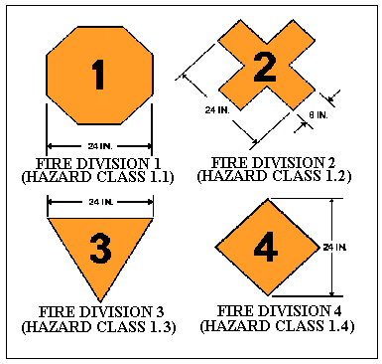

Shipments of explosives can be identified by diamond-shaped orange placards such as these:
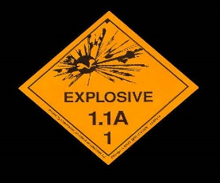
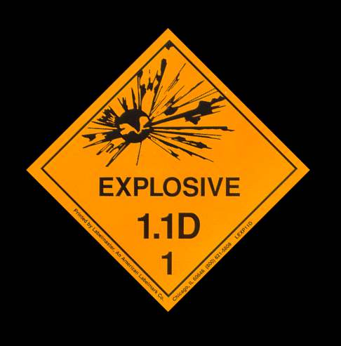
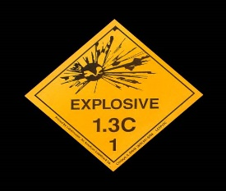
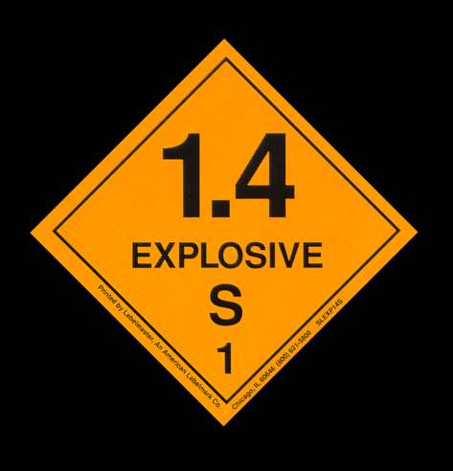

Differing Professional Opinions (DPO) Process

Point of Contact
Frank George, Jr. (806) 573-6801

Pantex is committed to ensuring that all of our employees are free to raise concerns, complaints and questions without fear of intimidation, reprisal or retaliation. In keeping this commitment, Pantex maintains a variety of well-established internal employee concern and complaint processes, including an internal Differing Professional Opinions (DPO) process.

Pantex employees are encouraged to first report concerns to their immediate supervisor, to any level of Pantex management or to internal organizations responsible for dealing with the particular subject matter of the concern in a good faith effort to resolve issues at the lowest possible level of the organization. In certain instances, an employee may decide that routine internal processes did not or cannot adequately resolve a concern. The DPO process exists for use in these instances. The DPO process is intended to supplement, not replace, existing internal processes designed to address employee concerns and complaints. The DPO process is not intended to be the first step used to report concerns or to be used as a way to bypass other internal processes.

In addition, Department of Energy (DOE) Order 442.2 Chg 1, establishes DOE’s DPO process and associated requirements. Pantex employees also have the right to report environment, safety and health technical concerns that have not been resolved through routine work processes through the DOE’s DPO process. DOE’s DPO process can be found in Attachment 2 of DOE Order 442.2 Chg. 1 and on the DOE’s DPO webpage located at: http://energy.gov/ehss/doe-differing-professional-opinions.

The following types of concerns are generally not within the scope of the Pantex DPO process:
- Concerns that are administrative in nature.
- Personnel concerns, such as performance elements, evaluations and ratings, or work assignments by management.
- Contract concerns such as cost/schedule performance, fees, or contract negotiations.
- Concerns related to collective bargaining including concerns that need to be addressed through the grievance process.
- Concerns that relate to fraud, waste, or abuse, as these issues should be referred to the Pantex Internal Audit, Ethics and Employee Concerns Office or the DOE’s Office of Inspector General.
- Concerns submitted anonymously or for which confidentiality is requested.
- Concerns that have been considered and already addressed by a DPO process or another internal evaluation process unless significant new information is available.
Pantex employees may submit these types of concerns through the Pantex Employee Concerns Program or other internal concern/complaint processes.

General Employee Radiation Training (GERT)
Points of Contact

Rick Jones (806) 477-5726
Kristin Riddles (806) 477-7042
Amber Kuntzelman (806) 477-4256

The material presented in the following section is General Employee Radiation Training (GERT) for subcontractors. This training material is provided to personnel who will require ENTRY into posted radiological areas or who could potentially receive occupational radiation exposure. Areas may include: radiological controlled areas, encountering radiological barriers, postings, radioactive material, or radiation producing devices.

Radiological work is defined as using, handling, moving or operating any radioactive material, or generating radioactive waste, and will require additional training. The following training must be completed prior to performing radiological work.
- Radiological Worker I (CR 7.06 and JT 7.10)
- Radiological Worker II (CR 7.04 and JT 7.12)

Contact your Pantex POC if additional Radiological Worker training is needed or you have questions concerning this information. Table 1 shows radiological posted areas personnel may enter with GERT training. Several radiological posted areas can be entered without an ESCORT while other areas require a radiological escort as well as completion and approval of the PX-5263, Checklist for Subcontractor/Visitor Access to Pantex Plant.

The need for dosimetry services may be required to enter some posted radiological areas. If a dosimeter is required, it can be requested by completing a PX-2868, Dosimetry Information Form. If there are any questions, call (806) 477-5726 or (806) 477-7042.

Table 1. Types of Posted Areas GERT Allows Entry
GERT Allowed Entry
Posted Radiological Areas | Pantex
Controlled Area | Yes—Does not require Rad Escort
Radioactive Material Area (RMA) | Yes—Does not require Rad Escort*
Radiation Area (RA) | No—ONLY under Rad Escort & RSD Approval*
High Radiation Area (HRA) | No
Very High Radiation Areas (VHRA) | No
Airborne Radioactivity Area (ARA) | No
Radiological Buffer Area (RBA) | No—ONLY under Rad Escort & RSD Approval*
Contamination Area (CA) | No—ONLY under Rad Escort & RSD Approval*
High Contamination Area (HCA) | No
Soil Contamination Area (SCA) | Yes—NO Soil Disturbance*
Fixed Contamination Area (FCA) | Yes—NO Disturbance of Fixed Contamination*
*No handling, using or touching of Rad Material

After completing GERT, participants will be able to identify:
- Hazards associated with radiological areas and radioactive material,
- Limitations as a trained general employee during access to or work in Controlled Areas
- Responsibilities for complying with radiological requirements, including his/her expected response to abnormal radiological events or emergencies.

Basic Radiation/Radiological Materials Fundamentals, and Radiation Protection Concepts

All matter is composed of atoms. Atoms are composed of three basic particles: protons, neutrons, and electrons. As shown, protons have a positive charge, electrons a negative, and neutrons have no charge. Most atoms contain a ratio of neutrons and protons that renders them stable. Stable atoms do not emit excess energy. Unstable atoms need to rid themselves of excess energy. This energy is called radiation. Simply stated, radiation is energy emitted through space in the form of particles or rays.

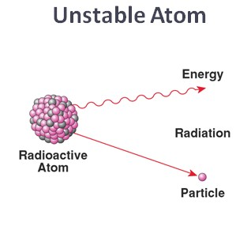
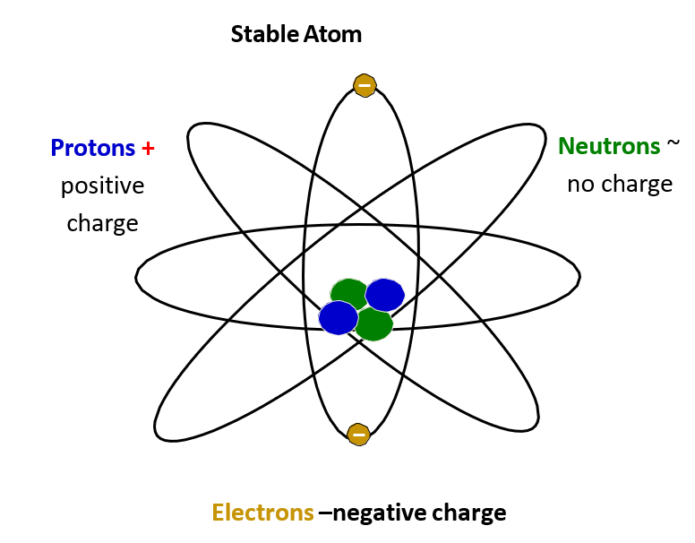

There are two types of radiation:
- Ionizing
- Non-Ionizing

The difference between the two types is their wavelength, frequency and their origin. The shorter the wavelength, the higher the energy. Radio waves have very large wavelengths, gamma rays have shorter wavelengths. The origin of radiation can be from the nucleus and/or the orbiting electron. The nucleus produces gamma and particulate radiation and the outer electron produce electromagnetic radiation.

Non-ionizing radiation does not have enough energy to remove an electron. Even though non-ionizing radiation is capable of causing biological damage, it is not a major radiological concern. Types of non-ionizing radiation include:
- Radio waves
- Microwaves
- Infrared
- Visible Light
- Ultraviolet Light

Ionizing radiation has enough energy to remove electrons, creating the potential for biological damage or dose. Ionizing radiation is the greatest concern.
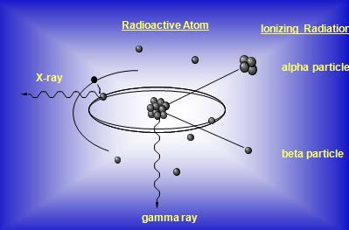
There are four basic types of ionizing radiation:
- Alpha particles
- Beta particles
- Neutron particles
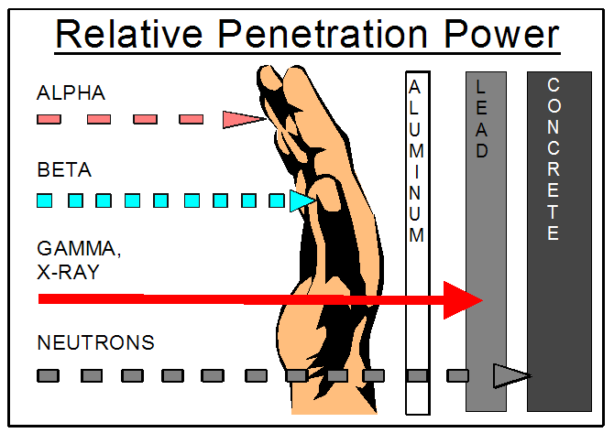
- Gamma/X-rays or waves
Alpha particles can be stopped by a layer of skin or a sheet of paper. Beta particles can be stopped by material such as aluminum or plastic. Gamma/X-rays must be shielded by extremely dense material like lead or tungsten. Neutron shielding must contain large hydrogen-rich material, such as water or concrete.

What is the difference between Radiation and Radioactive Contamination?
Contamination is radioactive material in an unwanted place or location. Exposure to radiation does NOT result in contamination of a worker. Only if a worker comes into contact with radioactive contamination would the potential exist for the worker’s skin or clothing to be contaminated.

Simply put, Radiation is energy and Contamination is unwanted radioactive material in a location. For example, radiation is like the heat felt from a campfire; contamination is like glowing embers from the camp fire landing on clothing.
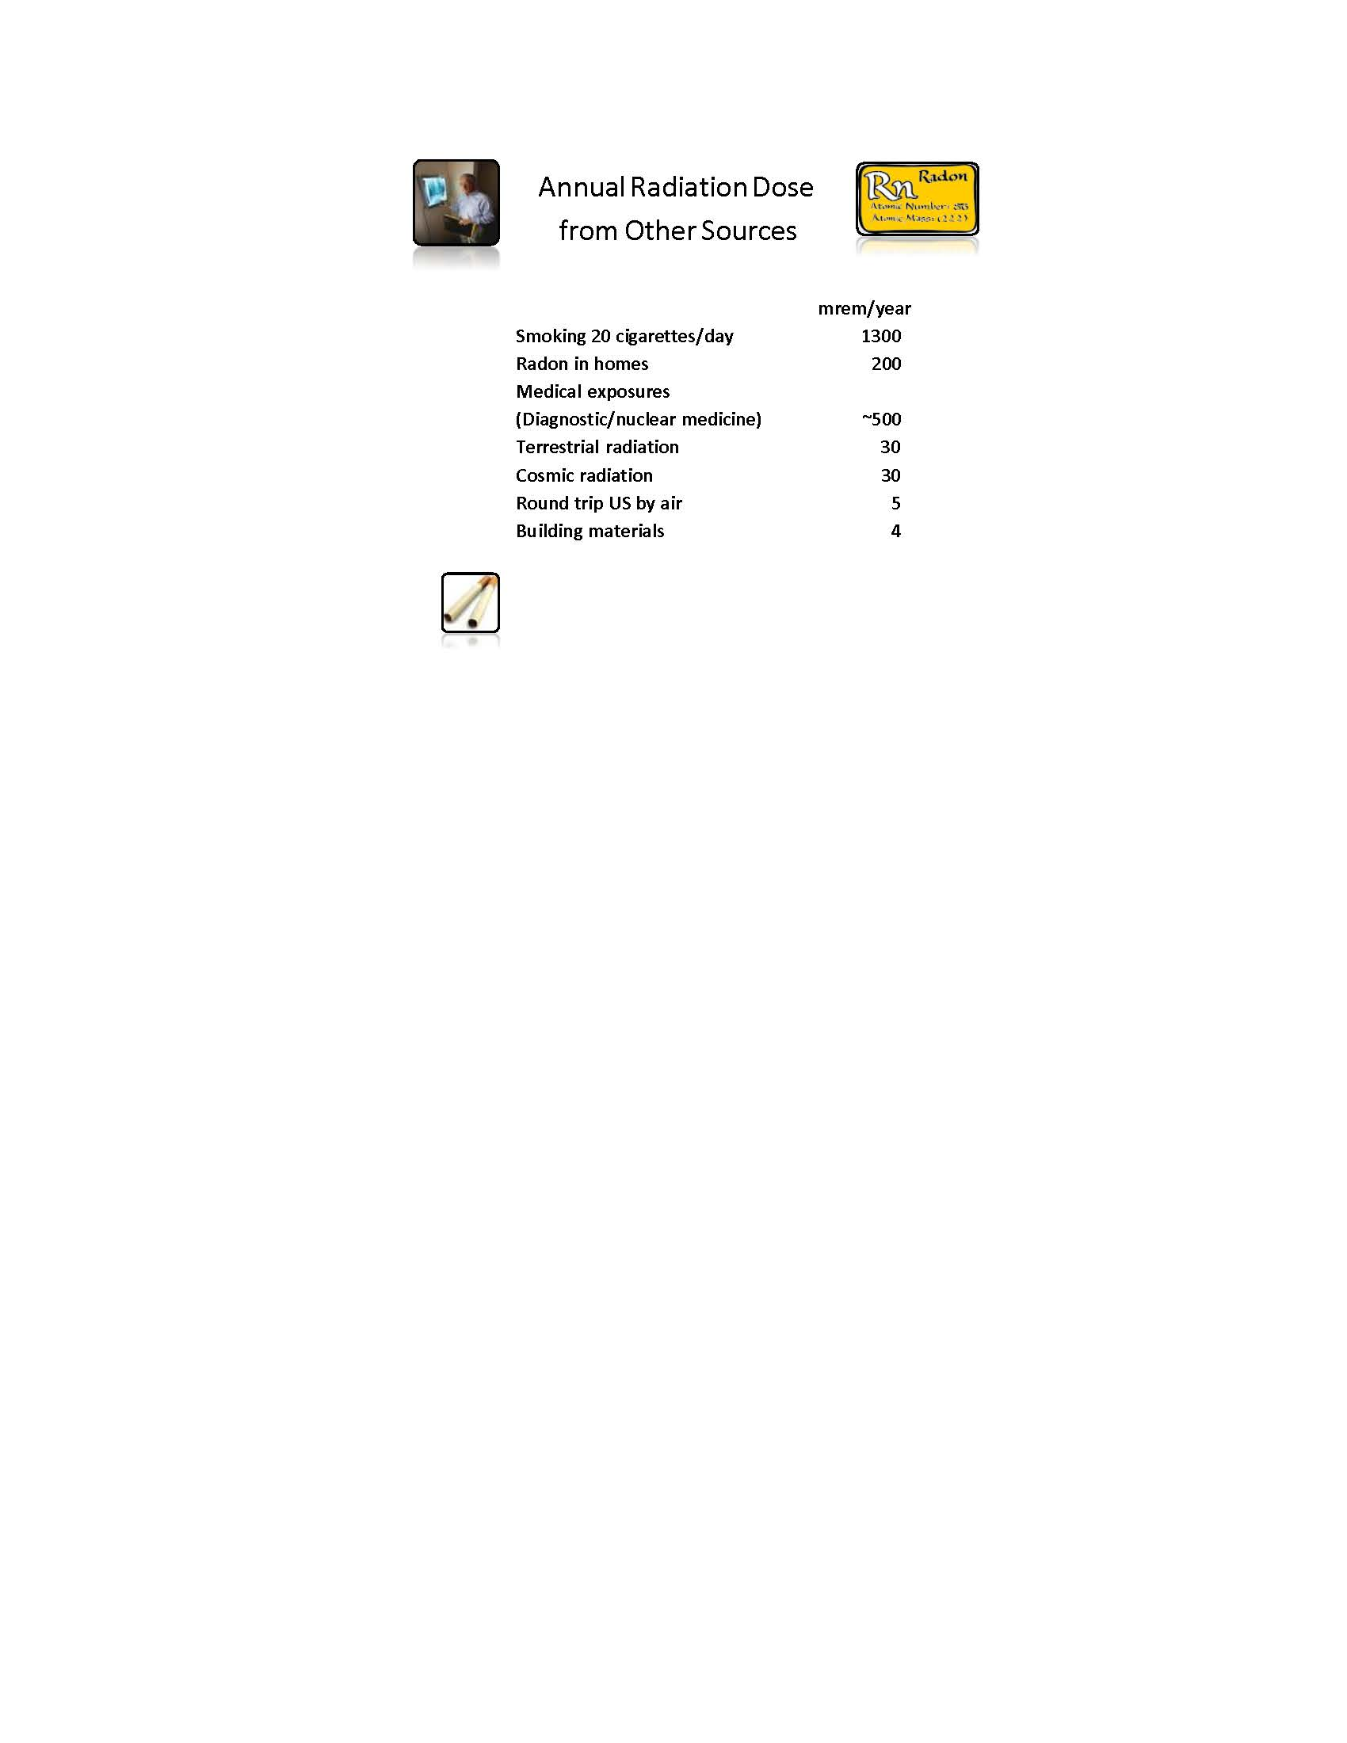

Sources of Radiation
Exposure occurs from natural and man-made radiation sources found in the environment, foods, medical procedures, and consumer products. The average U. S. annual background dose, to a member of the general population, is approximately 620 mrem per year and is an accumulation of both natural background and man-made sources of radiation. A"mrem" is the basic unit of measurement used to estimate the amount of biological injury that has occurred in cells due to radiation.

1 rem = 1,000 mrem

Natural background radiation
The main sources of naturally occurring radiation are:
- Radon – a gas from naturally occurring Uranium in the soil - 37%
- Cosmic/Space radiation - from the sun and outer space - 5%
- Internal - materials present in our bodies such as Potassium-40 ~5%
- Terrestrial radiation - materials in the earth's crust such as rocks and soil - 3%

Man-made sources of radiation
These contribute to the remainder of the annual average radiation dose. Man-made sources include the following:
- Medical uses such as x-rays and nuclear medicine ~48%.
- Consumer products such as smoke detectors, tobacco products, building materials - 2%

Sources of Radiation at Pantex
- Plutonium
- Uranium
- Tritium
- Thorium
- Radiation Generating Devices (RGDs)
- Sealed Sources

Risks of Exposure to Radiation and Radioactive Materials, Including Pre-Natal Radiation Exposure

Risks in Perspective
Annual background exposure is accounted for separately from occupational exposures received on the job. The risk associated with occupational exposures at Pantex is very small and is considered acceptable when compared to health risks in other occupations (for example, being a coal miner or a construction worker). The Department of Energy’s (DOE) whole-body radiation dose limit for general employees is 5,000 mrem/year. However, Pantex has set Administrative Control Levels (ACL) well below the DOE limit.

For Subcontractors the Pantex ACL for occupational exposure is 200 mrem per year. It is each person’s responsibility to comply with Pantex’s ACL. A suspected ACL of 200 mrem that is being approached or exceeded, requires immediate notification to the Pantex POC or Radiation Safety Department.

Although there is no scientific evidence for health effects from radiation doses below the annual DOE limit (5,000 mrem/year) for occupational exposure, Pantex assumes that any exposure, no matter how low, has an associated risk of health effects.

Health Effects
Biological effects from large doses of radiation may occur in the exposed individual or in the future children of the exposed individual. There is scientific evidence of health effects (cancer) from radiation doses well above the annual limit for occupational exposures (greater than 10,000 mrem).

Types of Exposure
- Chronic Exposure
Chronic exposure refers to small radiological doses repeated over a long period of time. Occupational exposure is an example of chronic radiation doses. Although, no evidence between chronic doses is linked to cancer, we assume that any exposure, no matter how low, has a risk to health.

Acute Exposure
Acute exposure refers to a large dose received over a short period of time. Acute exposure doses are typically received under accident conditions, such as Chernobyl. Effects from acute doses occur soon after the event.

Difference between Dose and Exposure?
- Dose is the amount of radiation absorbed by the body, which can damage the cells.
- Exposure is the amount of radiation measured in air.

Pre-natal Exposure
A developing fetus is especially sensitive to ionizing radiation due to rapidly dividing cells. Radiation dose to the fetus may increase the chances of lower birth weight, slower mental growth, or childhood cancer. These effects may also be caused by many other hazards in our environment such as smoking or consuming alcohol. The risk of these effects is minimized by implementing special protective measures for the embryo/fetus. A female working on site has the option to declare her pregnancy in writing using a PX-2820 form. The PX-2820 is provided to the Radiation Safety Department and Pantex OHS so that they may evaluate the need for potential work restrictions. Radiation Safety does NOT review any medical records. It is typically recommended that the declared pregnant radiation worker be re-assigned so that further radiation exposure during the pregnancy is unlikely.

Benefit versus Risk

Accepting a potential risk from ionizing radiation is a personal matter. Each individual must weigh the benefits against the potential risk of receiving a dose. There are many benefits received from ionizing radiation. However, because it may be harmful if too much ionizing radiation is received, personnel must learn to respect and learn to work safely with and around radioactive materials.

Radiological Controls
Radiological controls are established in order to protect individuals from exposure to radiation and intake of radioactive material. These controls include a unique identification system using certain colors, symbols and radiological postings.

All areas or materials controlled for radiological purposes are identified by one or more of the following:
- Signs having the standard radiation trefoil symbol and magenta colored lettering on a yellow background. At Pantex, postings used for training purposes are ONLY black and yellow.
- Yellow and magenta rope, tape, chains, or other barriers used to designate boundaries of posted areas.
- Tags and labels with a yellow background and a magenta standard radiation trefoil symbol used to identify radioactive material. Green tags indicate items have been surveyed and meet acceptable radiological release limits for unrestricted use.
- Radioactive material MUST be stored in a posted Radioactive Material Area (RMA) at a minimum.

Only specially-trained workers are permitted to enter areas controlled for radiological purposes. Additional radiological training is required in order to handle radioactive material.

Posted Areas GERT-trained personnel are allowed to enter, either escorted or unescorted
Below is a list of common postings that personnel may encounter. GERT trained personnel may enter several of these areas without a radiological escort, while entry into some areas require a radiological escort.

Controlled Area—an area that has been established to protect individuals from exposure to radiation and radioactive contamination. GERT WILL allow permission to enter a Controlled Area without a radiological escort.

Radiological Material Area (RMA)—an area where radioactive materials are used, handled or stored. GERT will permit entrance into a Radioactive Material Area without a radiological escort; however, touching, moving, or operating radioactive materials is NOT ALLOWED. Entrance requires a dosimeter.

Radiation Area (RA)—an area accessible in which radiation levels could result in an equivalent dose to the whole body in excess of 5 mrem in 1 hour at 30 centimeters from the source. GERT will NOT allow unescorted access to this area. Entrance requires an ESCORT and a dosimeter.

GERT trained personnel CANNOT perform radiological work.

Other posted radiological areas established within the Controlled Area at Pantex include the following:
- High Radiation Areas | - High Contamination Areas
- Very High Radiation Areas | - Soil Contamination Area (SCA)
- Radiological Buffer Area (RBA) | - Fixed Contamination Area
- Contamination Area | - Airborne Radioactivity Areas

GERT WILL NOT permit you to enter these areas unless additional radiological training is completed.

ALARA Concepts, practices and employee responsibilities
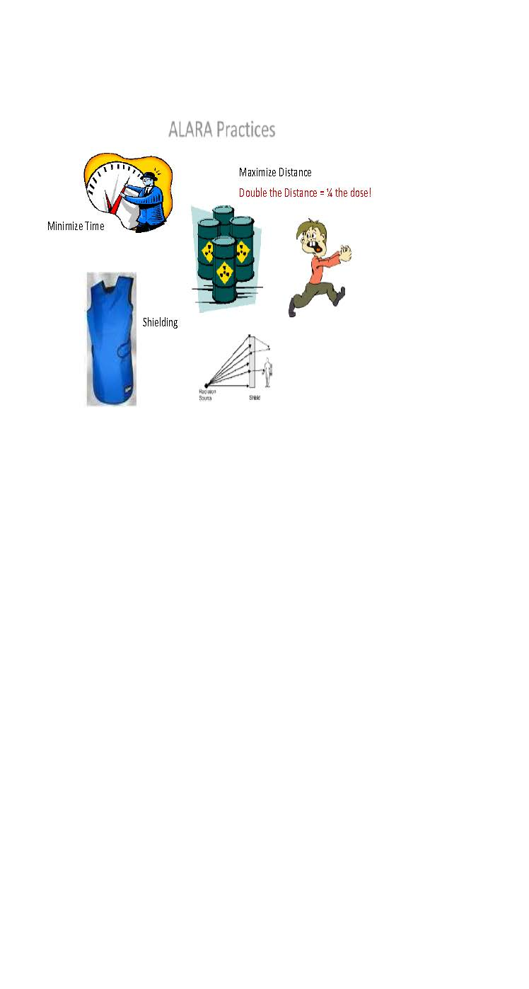
ALARA Concept
“As Low As Reasonably Achievable” (ALARA) is a process of managing radiation exposure and is designed to control occupational exposure ensuring occupational workers are well below regulatory limits. The ALARA Committee establishes annual goals; these are not regulatory limits. ALARA goals aid in ensuring regulatory limits are not exceeded.

There are three basic practices under ALARA that personnel may use to minimize exposures:
- Time - Reduce the amount of time spent near a radiation source.
- Distance - Stay as far away from the source as possible.
- Shielding - Utilize shielding between the workers and the source.

Correct responses to emergencies and/or alarms

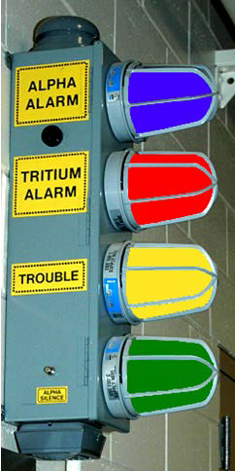
Radiological Emergency Procedures
However unlikely a radiological incident may occur, knowledge of emergency procedures is required. Follow all instructions announced over the public address system or provided by an escort and/or personnel in the immediate vicinity. Acknowledgement of an emergency alarm of any type requires reporting TO THE 24-HOUR OPERATIONS CENTER at (806) 477-5000.

Abnormal Conditions
If the discovery of radioactive material is found where it does not belong, the following actions should be taken:
- Do not touch, handle, operate, or move the material.
- Warn other personnel in the area.
- Guard the area at a safe distance.
- Call Radiation Safety at (806) 477-5555 and wait for Radiation Safety to arrive. ONLY Radiation Safety can release personnel from radiological alarms.

Signal | Meaning | Action
Blue Light  High Pitch Tone | Airborne Alpha Contamination | Exit Bay/Cell. Remove PPE in Interlock. Stand in Ramp at entrance. Send 1 person to call ext. 5000 or 5555 (Rad Safety). Control approaching personnel.
Red Light  Loud Bell | Airborne Tritium Contamination | Exit Bay/Cell. Remove PPE in Ramp. Continue to muster station. Do NOT interact with others. Call ext. 5000 or 5555. (Rad Safety).
Amber Light  Buzzer | Trouble/Malfunction | STOP WORK. Do not exit. Call ext. 5000 or 5555.
Green Light  No Sound | Normal Operations | Do NOT enter if there is NO green light. Call ext. 5000.

Workers are trained to evacuate within 5 minutes in the event of an accident involving radioactive material. In the event an accident with radioactive material occurs and there is no alarm, personnel should evacuate in 5 minutes or less.

Requirements of Dosimetry
Personnel Monitoring (Dosimetry)
Dosimetry detection devices used to detect occupational radiation exposure. Dosimetry is based on the job and location where work is to be performed. Persons who enter radioactive material areas must obtain a dosimeter prior to entry into the area.

Thermoluminescent Dosimeters
Thermoluminescent dosimeters (TLDs) are used to measure radiation from neutrons, gamma and x-rays, and all but very low-energy beta particles. Each dosimeter contains materials that, when exposed to radiation, will capture the type and amount of radiation to which the individual is exposed. Very sensitive instruments measure this exposure, and an individual’s dose is calculated from the data obtained.

NOTE: The TLD measures external occupational radiation doses and is not a shield.
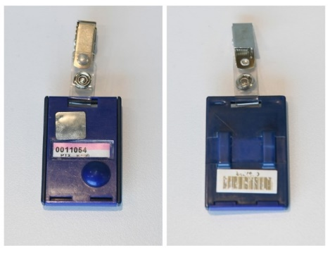

Wearing the Dosimeter
The dosimeter is to be clipped to clothing on the upper part of the body (on the torso, between the neck and the waist). Clipping the dosimeter to a belt or belt loop is acceptable. Do NOT hang the dosimeter on a neck lanyard or chain or place the dosimeter through the security X-ray machines.

Obtaining a Dosimeter
Persons who enter radioactive material areas must obtain a dosimeter prior to entry into the area. Dosimeters can be requested by completing a PX-2868, Dosimetry Information Form. If there are any questions, call (806) 477-6204 or (806) 477-7042. Having visited or worked at another facility where a dosimeter was issued requires a record of the doses received on the PX-2868, allowing Dosimetry to maintain a complete radiation dose history.

Dose Reports
Personnel are not expected to receive dose above their Pantex ACL (200 mrem/yr.). A radiation dose report will be mailed each time a Pantex dosimeter is processed. This report will be mailed to the address provided on the PX-2868 and details radiation doses for the current calendar year and contains year-to-date and lifetime doses received at Pantex. Personnel have the right to request, in writing, a dose report at any time.

Leaving Pantex
Return the issued dosimeter to the Pantex POC or leave it hanging on an official dosimeter storage location at the end of the visit. Pantex requires personnel to only wear the dosimeter that has been assigned to that person.

Medical Applications
Individuals who have recently been administered radionuclides for medical purposes should report their medical procedure to Pantex’s OHS at (806) 573-1396. Radionuclide injections or ingestion for medical purposes may sound the alarm on portal monitors at the security stations and entry will not be allowed.

Lost or Damaged Dosimeters
Should personnel lose or damage the dosimeter, exit the Radioactive Material Area and contact Dosimetry at (806) 477-4424 or (806) 477-4633 for a replacement. The dosimeter must be either on the issued personnel or on the storage board while on the Pantex site.

Summary
It is important to be aware of radiological risks and to take appropriate protective measures to minimize that risk by using time, distance, and shielding when in an area where radiation or radioactive contamination may exist. Through awareness and personnel responsibility, each individual who visits Pantex can contribute to a safe work environment. Any question may be referred to the Radiation Safety Department.

Responsibilities
Everyone has a responsibility to help maintain exposures to radiation As Low As Reasonably Achievable (ALARA). Planning work is the key to minimizing exposure and reducing dose.
- Acknowledge the receipt of GERT by signing the PX-3864
- If a TLD is required, complete the PX-2868, Dosimetry Information Form.
- Enter only those areas that GERT training allows (see Table 1).
- Obey all radiological signs/postings. Do NOT perform hands-on work in a radioactive material area.
- If issued a dosimeter (TLD), wear it clipped to clothing between the neck and waist. (Clipped to a belt or belt loop is acceptable.)
- Do not take the dosimeter off site. (The dosimeter is sensitive to extreme heat and excessive moisture.) Leave it hanging on an official dosimeter storage location at the end of the day.
- Utilize ALARA principles (minimum time, maximum distance, and shielding)
- Personnel should never walk in front of the area where a Tritium/Alpha alarm is going off.
- RWI is required to enter Radiation Areas Be alert and report unusual radiological situations to Radiation Safety at (806) 477-5555.

